# *Web Programming II (420-C20-HR)*

# *Lab 2 – Bootstrap*

Date assigned: Monday, January 25, 2016

Date due: **Monday, January 25, 2016, before the end of lab**

**Learning Objectives**

Upon successful completion of this lab exercise, the student will have:

* Created pages using bootstrap

Notes:

* Although you are welcome to use Dreamweaver this lab may be easier done with Notepad++. There may be times when you are updating multiple sections with the same information and may want to use the”Multi-Edit” setting in Notepad++. To use this, go to the first place you want to insert the information and then press the Ctrl key and select all the other places you want to insert. Then as you type you will update all the selected lines with the text you type. If this option is not turned on in your Notepad++, go to

Settings->Preferences->Editing and select Enable under Multi-Edit Settings.

* I have provided a template called template.html that links the bootstrap and jQuery JavaScript libraries and the bootstrap CSS all from CDN. You will need to add another stylesheet when instructed to.

To do:

**Part A – A Simple Set of Images**

1. To start, create a file called partA.html from the given template and attach a stylesheet from the styles folder called styles.css
2. In styles.css add properties for all section elements in the .teams class to align the text to the centre of the window.
3. In styles.css add a class called .icon which sets the maximum width to 150px, the margin top and bottom to 0 and the margin left and right to auto and displays as a block.
4. In partA.html add a div with the classes of services (the one you created in styles) and container (a bootstrap class).
5. Inside this div add a paragraph with the class h2 and the words Original Six Teams.
6. Add a div of class row still inside the container
7. Inside the row div add 6 sections. In each section add an image of class icon and link the images of the original 6 NHL teams found in the images folder. Link them in in alphabetical order. After each image add the team name as a heading 3 (use h3 this time) and the paragraph about them sound in the file teaminfo.txt. Note the image, h3 and paragraph all go in the section, with each section containing the information for one team.

When you’re done the page should look like this:

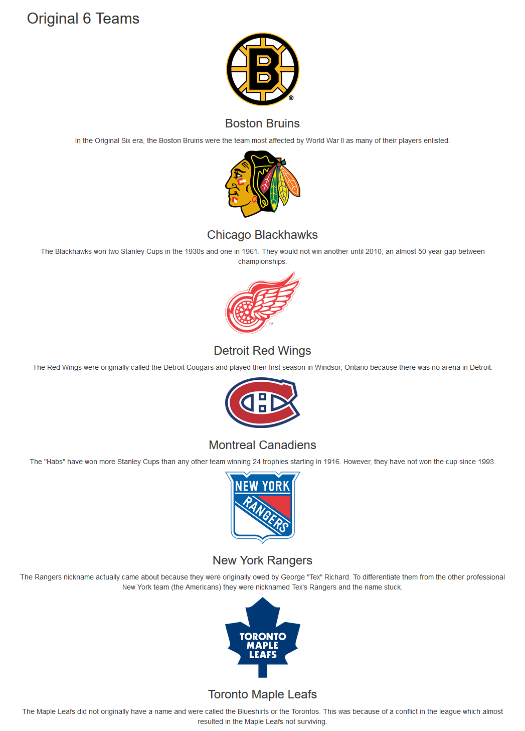

1. Add the appropriate bootstrap classes so that at the small breakpoint (sm) each section uses 6 columns, at the medium breakpoint, each section uses 4 columns and at the large breakpoint each section uses 2 columns.
2. When you view it in the browser the large size will look fine:  
   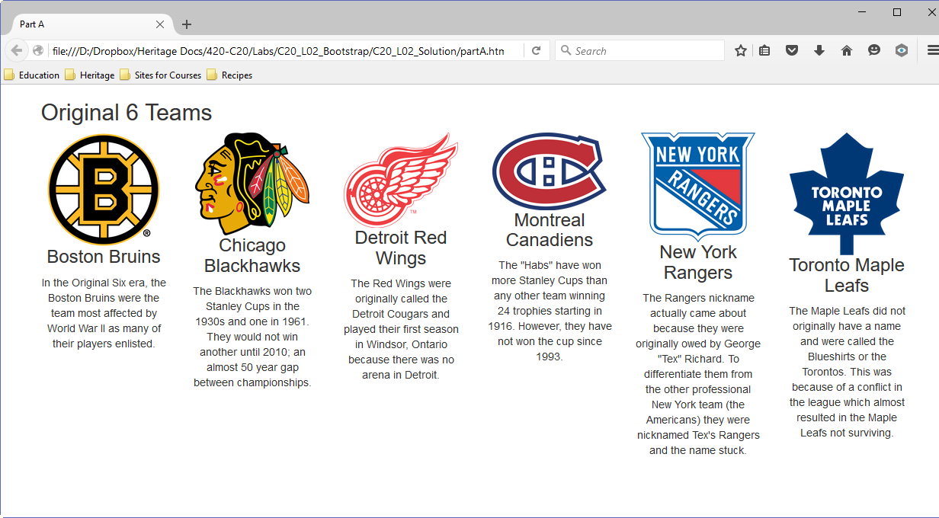
3. At the medium size, however, it looks like this:  
   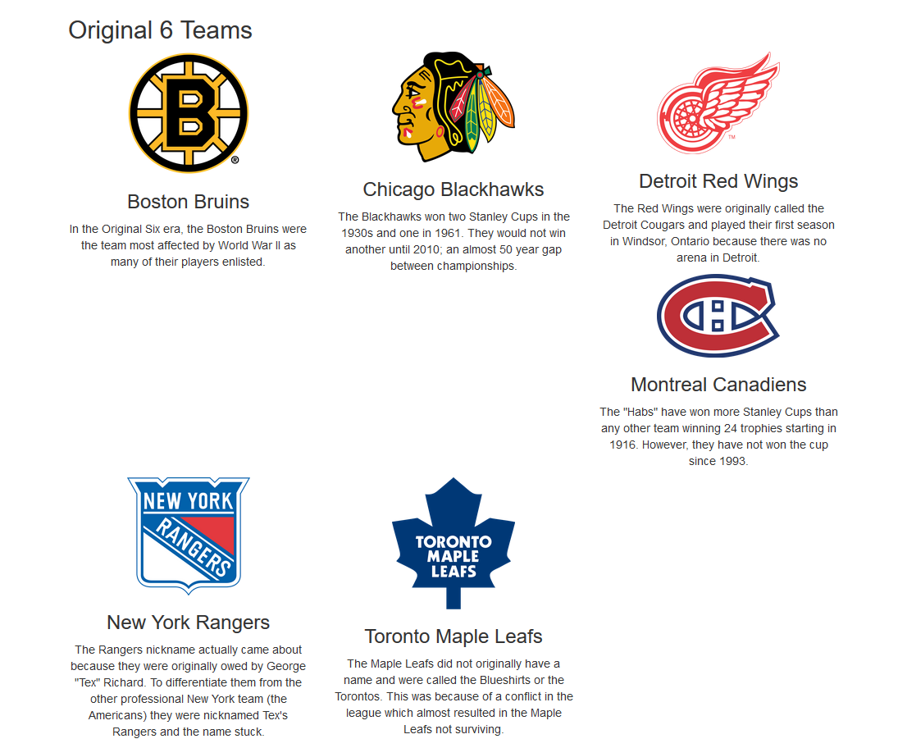
4. To fix this add a div with the class clearfix after the third section element (the Red Wings). You will have to make this div only visible (using a bootstrap class) at the medium breakpoint. The final result should be two rows of three at medium and still one row of six at large.
5. If you shrink the browser to the small breakpoint a similar problem occurs (actually after both rows. So you will have to apply the same technique to after the second and fourth sections (Blackhawks and Canadiens respectively). This time, make the clearfix div only visible at the small breakpoint.
6. At this point the page should display as 1 row of six at the large breakpoint, 2 rows of three at the medium breakpoint, 3 rows of two at the small breakpoint and 6 rows of 1 at the extra-small breakpoint.
7. At the extra small breakpoint, the text, although centred, does not look good being too wide for the image. To correct this, add three more classes to each section element. The first class offsets the section by 3 at the extra small breakpoint. The second class sets the extra small class to only take 6 columns. The third class clears the offset by setting it to zero at the small breakpoint.
8. The final results at each breakpoint are pictured in images found in the solutionimages folder.

**Part B – A Different Look at Large**

1. Copy partA.html to partB.html. You should continue to use the same CSS file.
2. In this part we are going to change the look of the large breakpoint so that the images and blurbs are listed down the page.
3. Start off by modifying the section element so that, at the large breakpoint, each section takes 12 columns.
4. Now, inside each section add a div with the class row immediately after the section tag. End this “inner row” just before the end of section tag; that is, all three elements in the section are also contained in the div of class row.
5. Add a class to the image (img) element so that the image takes only one column at the large breakpoint.
6. Add a new div around the h3 and p elements so that div takes 5 columns at the large breakpoint.
7. To both this div and the img tag add a class (as the first class listed) to push the contents three columns.
8. In the styles.css file you will need to make some changes so that things align properly. Add a media query for the large breakpoint (minimum width 1200px). Inside this query add an h3 property where the top margin is set to 0. Also, add a property to change the section with the teams class so that the text is left-aligned.
9. Now at the large breakpoint (and only the large breakpoint) the page should look like this:  
   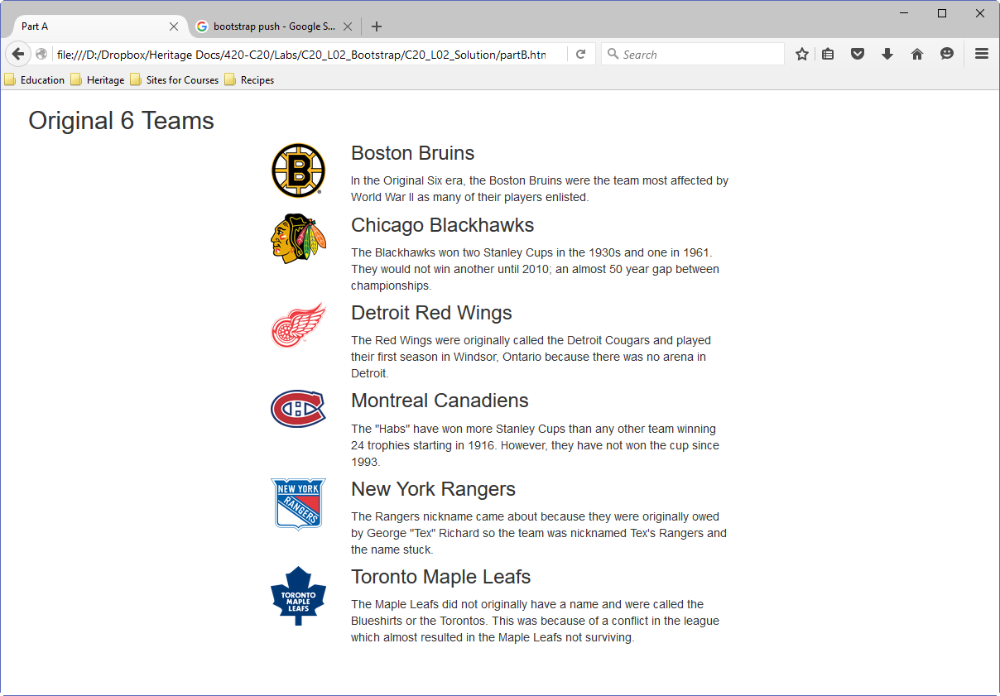

**Part C – Buttons**

1. Using the template, create a webpage called partC.html. Give it a title.
2. Add a div which contains a fluid container. Inside the container add a div with class row and inside the class add a section with a class indicating that the extra small breakpoint uses all 12 columns.
3. Inside the section add an h2 with the words Buttons.
4. Add 6 anchor tags that link to the absolute URL for the original six hockey teams. The URLs are: http://*teamnickname*.nhl.com where *teamnickname* is the nickname of the team (Bruins, Blackhawks, RedWings, Canadiens, Rangers and MapleLeafs). At this point you may want to test your page to make sure the links work.
5. Now add classes to change each link into a button, Give each button a different types (6 links and 6 types of buttons). The final page should look something like this:

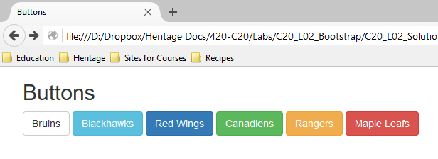

**To submit**

When you have completed the lab exercise call me over and we will review it/mark it together. You will also need to zip the file and copy it to Moodle.